*رابط النظام
ARARSS download | SourceForge.net

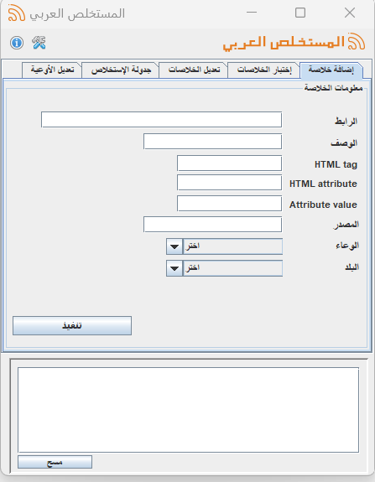

*الورقة العلمية
Al-Thubaity A., Alhoshan M. (2019). ARARSS: A System for Constructing and Updating Arabic Textual Resources. In: Hassanien A., Tolba M., Shaalan K., Azar A. (eds) Proceedings of the International Conference on Advanced Intelligent Systems and Informatics 2018. AISI 2018. Advances in Intelligent Systems and Computing, vol 845. Springer, Cham

