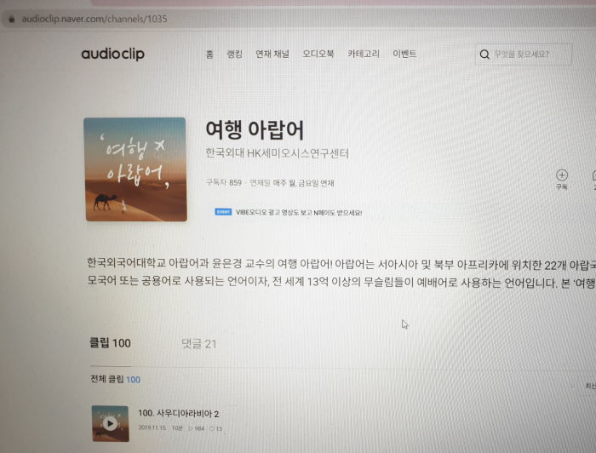

https://audioclip.naver.com/channels/1035/clips/99#chapter

